My Carbon impact application.

I know that how we live our lives has a massive impact on the environment. I want a little help with trying to reduce my Carbon foot print. I want to monitor my everyday activities and get an idea as to their effect on the environment. I intend to use this to change my lifestyle slightly and be more environmentally friendly.

I want you to write an application to record relevant activities and a guesstimate of their effect on the environment. I want to see a weekly total figure.

e.g. walking to work 10 points

Eating a 8oz steak -10 points

Cycling to the shops 5 points

Driving to work -5 points

Leisure drive -3 points per 10km

Vegetarian for a day +7 points

Cycling to work 7 points

Etc…

Elements stored activity (String) points (integer range -10 to 10) dates weks etc.

Use an arraylist of activity objects.

Write a javafx desktop application with a Gui like the following as a starting point.

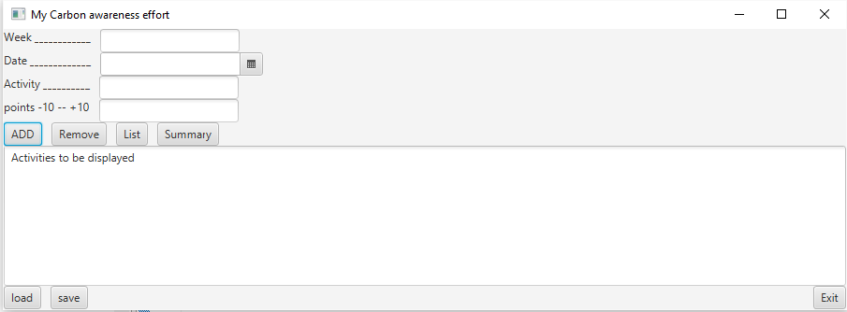

Part 1. Week 3 (10 Marks)

Use an arraylist of objects(activities) to store the information inputted by the Add button above.

Display all information in the text area. It contains the text from the arraylist of activities.

An activity can be removed from the arraylist.

List updates the list of activities displayed (with no totals)

Summary add a total points.

Load and save do as they imply: load and save the information to or from a file.

Part 2. Week 5 (10 Marks)

Change the application so that it uses a Tabbed pane.

* Tab 1 will be an intro tab
* Tab 2 will be the activity management tab same as above input/save etc. (This time you must use serialization).
* Tab 3 will be the results Tab. Here I want to see all the activities ordered by date or by activity (Use a button to select either ordering). Supply suitable totals in each.

Make sure you use a good layout for the items on each tab. Do not make it too simple.

Adjust the application so that the text describing the activities can be selected from a drop down list of some type (this may involve the use of another app to add or remove activities and a file).

Part 3. Week 7 (10 Marks)

Show the use of the following in your previous application:

* JavaDoc
* Junit testing with a test suite
* A good package structure (Maybe use Mavin)
* MVC
* Generate an executable jar file
* Create a non-executable jar file (as simple as you like) import it and use it in your project
* Show memory usage of your project and create a situation where the application uses too

much memory. An extra button that make the application create and store loads of objects

will do.

From week 7 onwards students will also be working on a project which will involve a dataBase.

https://docs.oracle.com/javafx/2/get_started/hello_world.htm